Week 3 Tutorial – Problem Solving Process

Step 1: Understand and Define the Problem (Analyse)
This task needs to design a combinational logic circuit. When the car is started, If the driver or the passenger seats is occupied and the seatbelt is not fastened, the alarm will be actived(LOW).

Step 2: Organise and Describe the Data
Input: IGN(Ignition Status),
DRIV(Driver in the seat
PASS(Passenger in the seat
BELTD(Driver’s seatbelt
BELTP(Passenger’s seatbelt

Output: ALARM

Step 3: Plan the Solution (Design the Algorithm)
3.1 Algorithm (in plain English)
1. Monitor ignition status: IGN must be HIGH
2. Check if driver is seated and driver’s belt is not fastened
3. Check if passenger is seated and passenger’s belt is not fastened
4.If either condition above is TRUE and IGN=1, the alarm activates
5. Otherwise, alarm remains HIGH or 1

3.2 Truth Table
DRIV | BELTD | PASS | BELTP | IGN | ALARM
1 | 1 | 1 | 1 | 1 | 0
1 | 1 | 1 | 0 | 1 | 0
1 | 1 | 0 | 1 | 1 | 0
1 | 1 | 0 | 0 | 1 | 0
1 | 0 | 1 | 1 | 1 | 0
1 | 0 | 1 | 0 | 1 | 0
1 | 0 | 0 | 1 | 1 | 0
1 | 0 | 0 | 0 | 1 | 0
0 | 1 | 1 | 1 | 1 | 0
0 | 1 | 1 | 0 | 1 | 1
0 | 1 | 0 | 1 | 1 | 0
0 | 1 | 0 | 0 | 1 | 0
0 | 0 | 1 | 1 | 1 | 0
0 | 0 | 1 | 0 | 1 | 1
0 | 0 | 0 | 1 | 1 | 0
0 | 0 | 0 | 0 | 1 | 0

3.3 Boolean Expressions (SOP)
DRIV.^BELTD.^PASS.^BELTP.IGN
DRIV.^BELTD.^PASS,BELTP.IGN
DRIV.^BELTD. PASS,^BELTP.IGN
DRIV.^BELTD. PASS,BELTP.IGN
DRIV.BELTD.PASS,^BELTP.IGN

ALARM=DRIV.^BELTD.^PASS.^BELTP.IGN+DRIV.^BELTD.^PASS.BELTP.IGN+DRIV.^BELTD.PASS.^BELTP.IGN+DRIV.^BELTD.PASS.BELTP.IGN+DRIV.BELTD.PASS.^BELTP.IGN
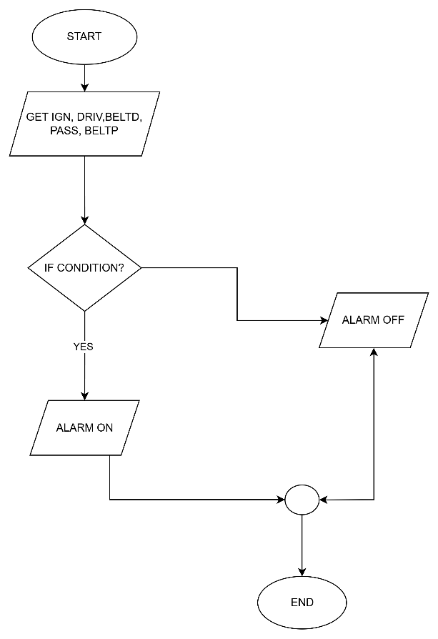
3.4 Flowchart

3.5 Pseudocode

Step 4: Test and Refine the Solution (Debug and Verify)

